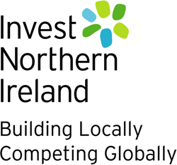
INNOVATION VOUCHERS INITIATIVE DIRECTORY OF SKILLS AND EXPERTISE

Knowledge Provider | National Composites Centre
Address | NCC, Bristol & Bath Science Park, Feynman Way, Emersons Green, Bristol, BS16 7FS
Contact Name | Leah Rider
Telephone Number | 07384 516421
Email Address | Leah.rider@nccuk.com

Department/Unit | Specific services offered | Contact  Name | Address  (If Different from  Above) | Telephone | E-Mail address
NCC Connect – SME Support | Composite material, process and technology research and development, specifically for SMEs – covering full design, build, test lifecycle.  Free of charge services include supply chain connections, line walks of manufacturing facilities and innovation workshops for new product introduction / technology assessments.  Matched funding available for eligible SMEs / projects.  More details available here: https://www.nccuk.com/sectors/supporting-smes/ | Leah Rider  Helen Woods |  |  | connect@nccuk.com  training@nccuk.com
NCC Connect - Training | Theoretical and practical off-the-shelf training courses on composites, digital and sustainable manufacturing.  Workforce development assessments (skills gap analysis) and bespoke programmes can be delivered to customers.  Delivery options include face to face (at the NCC or customer’s facility, dependent on equipment available), online live sessions, and online self-paced learning.  More details available here: https://www.nccuk.com/training/

