
A Guide to the Rural Needs Act (NI) 2016 for Public Authorities
(Revised) April 2018
Appendix 1 - Rural Needs Impact Assessment (RNIA)
Template
The main objective for Invest Northern Ireland in the design and delivery of this programme is to accelerate the growth of a small number of high potential food & drink companies through insights driven innovation. These companies will then be role models and case studies to demonstrate the effective use of insights in innovation and business growth.

1E. Please provide details of the aims and/or objectives of the Policy, Strategy, Plan or Public Service.
Growth through Insights Programme
1D. Please provide the official title (if any) of the Policy, Strategy, Plan or Public Service document or initiative relating to the category indicated in Section 1C above.

Developing a Policy Strategy Plan

Adopting a Policy Strategy Plan

Implementing a Policy Strategy Plan

Revising a Policy Strategy Plan Designing a Public Service
Delivering a Public Service

X
1C. Please indicate which category the activity specified in Section 1B above relates to.
Growth through Insights Programme. This is a capability development programme aimed at accelerating the growth of a small number of high potential food & drink companies through insights driven innovation.
1B. Please provide a short title which describes the activity being undertaken by the Public Authority that is subject to Section 1(1) of the Rural Needs Act (NI) 2016.
Invest NI
1A. Name of Public Authority.
SECTION 1 - Defining the activity subject to Section 1(1) of the Rural Needs Act (NI) 2016

A Guide to the Rural Needs Act (NI) 2016 for Public Authorities
(Revised) April 2018

N/a

Reasons why a definition of ‘rural’ is not applicable.
N/a

Rationale for using alternative definition of ‘rural’.
N/a
Details of alternative definition of ‘rural’ used.

Population Settlements of less than 5,000 (Default definition). Other Definition (Provide details and the rationale below).
A definition of ‘rural’ is not applicable.

X
1F. What definition of ‘rural’ is the Public Authority using in respect of the Policy, Strategy, Plan or Public Service?

A Guide to the Rural Needs Act (NI) 2016 for Public Authorities
(Revised) April 2018

2C. If the Policy, Strategy, Plan or Public Service is likely to impact on people in rural areas differently from people in urban areas, please explain how it is likely to impact on people in rural areas differently.

2B. Please explain how the Policy, Strategy, Plan or Public Service is likely to impact on people in rural areas.

Yes No If the response is NO GO TO Section 2E.
X

2A. Is the Policy, Strategy, Plan or Public Service likely to impact on people in rural areas?
SECTION 2 - Understanding the impact of the Policy, Strategy, Plan or Public Service

A Guide to the Rural Needs Act (NI) 2016 for Public Authorities
(Revised) April 2018

Food and Drink companies are located across Northern Ireland and are not disproportionately located in Rural areas. However, where businesses in this sector are located in these areas, we would anticipate a positive impact.

The delivery of the service to Clients will be a combination of physical and digital workshops and one2one meetings. No barriers to rural dwellers are anticipated.

2E. Please explain why the Policy, Strategy, Plan or Public Service is NOT likely to impact on people in rural areas.
If the response to Section 2A was YES GO TO Section 3A.

Rural Businesses Rural Tourism Rural Housing
Jobs or Employment in Rural Areas Education or Training in Rural Areas
Broadband or Mobile Communications in Rural Areas Transport Services or Infrastructure in Rural Areas Health or Social Care Services in Rural Areas
Poverty in Rural Areas Deprivation in Rural Areas
Rural Crime or Community Safety Rural Development
Agri-Environment

Other (Please state)

2D. Please indicate which of the following rural policy areas the Policy, Strategy, Plan or Public Service is likely to primarily impact on.

A Guide to the Rural Needs Act (NI) 2016 for Public Authorities
(Revised) April 2018

3C. Please provide details of the methods and information sources used to identify the social and economic needs of people in rural areas including relevant dates, names of organisations, titles of publications, website references, details of surveys or consultations undertaken etc.

Consultation with Rural Stakeholders Published Statistics Consultation with Other Organisations Research Papers Surveys or Questionnaires Other Publications
Other Methods or Information Sources (include details in Question 3C below).

3B. Please indicate which of the following methods or information sources were used by the Public Authority to identify the social and economic needs of people in rural areas.

Yes No If the response is NO GO TO Section 3E.
X

3A. Has the Public Authority taken steps to identify the social and economic needs of people in rural areas that are relevant to the Policy, Strategy, Plan or Public Service?
SECTION 3 - Identifying the Social and Economic Needs of Persons in Rural Areas

A Guide to the Rural Needs Act (NI) 2016 for Public Authorities
(Revised) April 2018

This policy is open to Invest NI Food and Drink Client Companies. These companies are located throughout Northern Ireland and are not disproportionately located in rural areas as mentioned above. Where Client Companies are located in rural areas we anticipate a positive impact in terms of the economy and wider impact on rural dwellers.

3E. Please explain why no steps were taken by the Public Authority to identify the social and economic needs of people in rural areas?
If the response to Section 3A was YES GO TO Section 4A.

3D. Please provide details of the social and economic needs of people in rural areas which have been identified by the Public Authority?

A Guide to the Rural Needs Act (NI) 2016 for Public Authorities
(Revised) April 2018

N/a

4A. Please provide details of the issues considered in relation to the social and economic needs of people in rural areas.
SECTION 4 - Considering the Social and Economic Needs of Persons in Rural Areas

A Guide to the Rural Needs Act (NI) 2016 for Public Authorities
(Revised) April 2018

If the response to Section 5A was YES GO TO Section 6A.

5B. Please explain how the development, adoption, implementation or revising of the Policy, Strategy or Plan, or the design or delivery of the Public Service, has been influenced by the rural needs identified.

Yes No If the response is NO GO TO Section 5C.
X

5A. Has the development, adoption, implementation or revising of the Policy, Strategy or Plan, or the design or delivery of the Public Service, been influenced by the rural needs identified?
SECTION 5 - Influencing the Policy, Strategy, Plan or Public Service

A Guide to the Rural Needs Act (NI) 2016 for Public Authorities
(Revised) April 2018

Rural Needs Impact Assessment undertaken by:
Thelma Fitzgerald
Position/Grade:
DP
Division/Branch
Food and Drink Division

Signature:
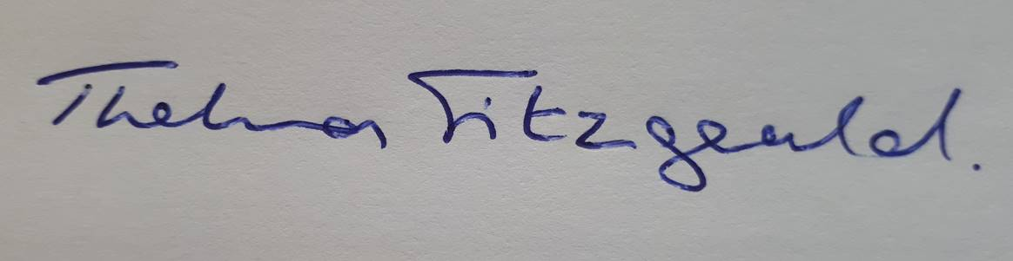
Date:
26/06/23
Rural Needs Impact Assessment approved by:
Pamela Marron
Position/Grade:
DP
Division/Branch:
Equality - Performance, Compliance and Coordination
Signature:
Pamela Marron
Date:
25/07/23

I confirm that the RNIA Template will be retained and relevant information compiled.

X
6A. Please tick below to confirm that the RNIA Template will be retained by the Public Authority and relevant information on the Section 1 activity compiled in accordance with paragraph 6.7 of the guidance.
SECTION 6 - Documenting and Recording
This policy is open to Invest NI Food and Drink Client Companies who meet the relevant criteria to be eligible for support. These companies are located throughout Northern Ireland and are not disproportionately located in rural areas. No specific rural needs were therefore identified.

5C. Please explain why the development, adoption, implementation or revising of the Policy, Strategy or Plan, or the design or the delivery of the Public Service, has NOT been influenced by the rural needs identified.

