

INITIAL EQUALITY SCREENING FORM
DIVISION: | People & Culture |  |  | TEAM: | Human Resources
Name of Policy/Decision/Practice to be Equality Screened
Graduate Gateway Programme

Is it New or Revised? |  | New
Who Does the Policy Effect, e.g Service Users/Staff: |  |  | Graduates or post-graduates
Question 1 – Define the aim of the Programme or . What is it trying to achieve? (Intended aims/outcomes)
Only 9% of external applicants are successful for Client Executive roles and this means that we need to develop an internal talent pool for these key ‘hard to fill’ roles. The aim of the 2 year Graduate Gateway Programme is therefore to develop Graduates for Client Officer roles and build a high calibre internal talent pool for future Client Executive roles.

The process will include:
- Application form
- Online testing – early career/Graduate test bank
- Sifting of application form
- Assessment centre – interview, presentation, group assessment
Criteria to be considered for the programme:
- Have or expect to have by August 2026, a minimum of a 2:2 degree classification or a post-graduate qualification
- Eligibility to work in the UK
- Willing to work at any of our offices across Northern Ireland to fulfil the Graduate Programme requirements
- Available to attend an assessment centre between Monday 23rd and Friday 27th March
- Able to commence on Monday 7th September 2026
- Current driving licence or have access to transport to meet the requirements of the Programme
Online testing will be the first stage assessment. This will allow us to use an objective assessment to measure key cognitive ability in a fair and unbiased way. It will also provide us with the flexibility to manage multiple applications which is crucial to being able to reduce the number of applicants to a more manageable number to take through to the assessment centres.

A cut-off will be applied and those within that group will be subject to a review of their responses to the criteria outlined above, progress to the next stage will be based on their responses. This is a similar approach to what NICS does and ensures a high volume of applications can be managed within a short timeframe.

A total of 30 candidates will be invited to attend the assessment centres and the remaining candidates will be retained on file for future requirements.

This process will be outlined to candidates in the Candidate Booklet and the FAQ document.

The assessment centre will be similar to the current process and comprise:
- Interview
- Assessment
- Group assessment
Upon completion of the assessment centre, 6 candidates will be offered places on the Programme.

The programme will be for a 2-year period. During the Programme the Graduate will undertake:
- 6 months comprehensive Induction & onboarding: understanding Invest NI’s role and deep learning period
- 6 months shadowing a Client Officer in Belfast team
- 6 months working in a regional team
- 6 months in an Assistant Client Officer role
A probation period will be applicable during the first 9 months of the programme – this is in line with the current Probation Policy. Throughout the programme, the Graduate will complete milestone assessments based on their learning – these are in the process of being developed and will align to the competencies required for Client Officer. Every effort will be made to ensure success at each milestone assessment, and it is anticipated that all Graduates will successfully complete the Programme.

A group project will also be assigned cc month 7 where the Graduates will be given a project to complete on something relevant to the business such as researching new markets. This will not be assessed but feedback will be given to Graduates on their contribution to the project.

Upon completion of the Programme, a final assessment will be made before progression to a vacant Client Officer role. This is likely to be based on a final project where they will outline their key learnings from the programme and provide feedback on the Programme structure and content.

The benefits of the programme are:
- Talent Pipeline: create a talent pipeline of fresh talent into the organisation: this helps in building a robust pipeline of future leaders who are well-versed in the company's culture, values, and business strategies.
- Skill Development: Graduate programmes are designed to provide comprehensive training and development opportunities. This helps graduates acquire the necessary skills and knowledge required for key client officer and executive roles, ensuring they are well-prepared to handle the responsibilities and challenges of these positions.
- Retention and Loyalty: Investing in the development of graduates fosters a sense of loyalty and commitment to the organisation. Graduates who feel valued and see clear career progression opportunities are more likely to stay with the company long-term, reducing turnover rates. This will also Enhance our brand as an employer of choice and promote Invest NI
- Innovation and Fresh Perspectives: Graduates often bring new ideas and perspectives. Their fresh outlook can drive innovation and help the organisation stay competitive in a rapidly changing business environment.
- Client Relationships: Key client officer and executive roles require individuals who can build and maintain strong relationships with clients. Graduates who are trained and developed through a structured programme are better equipped to understand client needs, provide exceptional service, and contribute to the overall success of the business.
- Succession Planning: A graduate programme helps in identifying and developing potential successors for key client executive roles. This ensures that there is a smooth transition and continuity in leadership, which is vital for maintaining client trust and business stability.

Question 2 – Does the Programme or have the potential to have an impact on the promotion of equality impact for any of the Section 75 groupings? (See Question 4 for list of equality groups.) |  |  |  |  |  | /No
If no go to Question 6 – Good Relations. |  |  |  | If yes please continue.
The programme is available to candidates who have a minimum 2.2 degree in any discipline including post-graduate qualification. The benefits of the programme ae outlined in Section 1.

The Programme is open to all age groups and there is no requirement to have completed the qualification in a certain timeframe therefore it may have a positive impact on older individuals who completed their degree many years ago, females returning to work after a period away for caring responsibilities or other, or those seeking a change of career. It is also open to current employees who meet the criteria.

It may also have a positive impact on younger age groups who have just completed their qualification and are seeking their first job. Our current workforce age profile shows that 45.45% of employees are aged 41–50, and only 24.24% are aged 21–30, with minimal representation in younger age bands. Attracting younger applicants would help to address a potential succession planning risk as a significant portion of staff will approach retirement in the coming years.

The Graduate Programme salary is graded as EOI which is in line with NICS.

The Graduates will be required to complete milestone assessments throughout the programme which they must pass to continue on the programme. At the end of the programme there will be one final assessment (TBC but likely the final project and presentation). If the Graduate successfully completes all assessments including final assessment, they will be offered a Client Officer role – location to be confirmed dependant on requirements at the time of appointment. Progression to future Client Executive roles will be subject to a normal recruitment process.

If a graduate does not meet the required standards during the Programme or at the final assessment stage, the organisation will review their continued employment in line with relevant HR policies (including the Probation Policy) and all applicable legislative requirements. Following this review, a range of outcomes may be considered, up to and including termination of employment.

Consideration of Available Data/Research
Question 3 – What is there available – statistics or perception – to help you decide who the Programme or might affect the most? i.e. What evidence, qualitative or quantitative, have you gathered to inform your decision making process?
Independent Review of Invest Northern Ireland (InvestNI) | Department for the Economy
Student Profile by Campus
Mature Students | Study | Queen's University Belfast
Who's studying in HE? | HESA
INVEST NI
Age Band | No. of staff
<21 | 2
21-30 | 33
31-40 | 75
41-50 | 215
51-60 | 200
>60 | 61
No Age | 82
 | 668
CLIENT EXECUTIVES/CLIENT FACING EXECUTIVES
Age Band | No. of staff
<21 | 0
21-30 | 3
31-40 | 5
41-50 | 32
51-60 | 28
>60 | 12
 | 80
GRADE (DP)
Age Band | No. of staff
<21 | 0
21-30 | 8
31-40 | 29
41-50 | 70
51-60 | 71
>60 | 26
 | 204

Census 2021: No qualifications for 24% of over 16s in NI - BBC News:
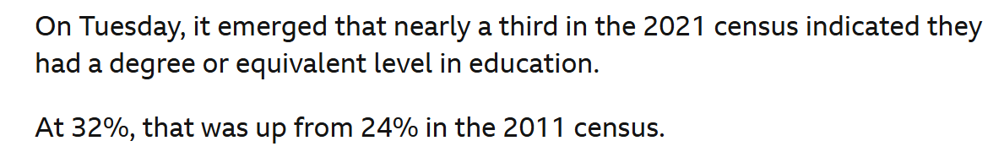

Have graduate jobs really nose-dived? | ISE
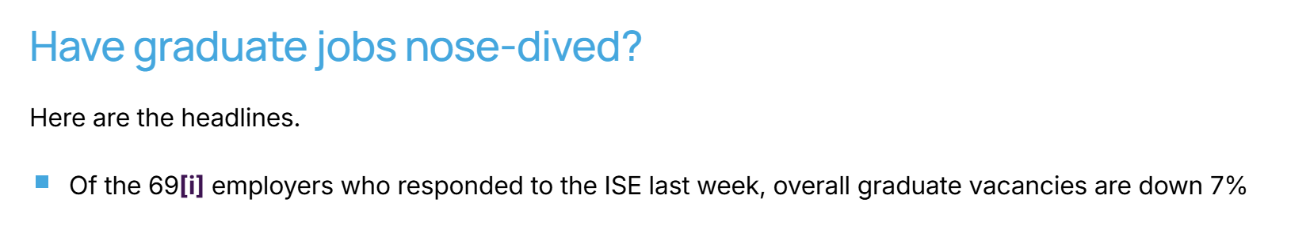

Northern Ireland Employer Survey Shows Falling Skills Shortages but Ongoing Recruitment Challenges - The Brief NI

Here's why the UK graduate job market feels so broken right now

Assessment of Impact
Question 4 – Explain if what you plan to do is likely to be perceived as having a high, medium or low impact upon the 9 Equality groupings according to their needs. Also if what you are planning to do is likely to be perceived as having a positive or negative effect upon the 3 different groups in relation to the promotion of good relations.
9 Equality Groups | Perceived Impact  High – (H)  Medium - (M)  Low – (L) | Why this rating? | Promotion of Good Relations  (Yes/No) | Why this rating?
Religious Belief | Low |  | N/A | N/A
Racial/Ethnic Group | Low |  | N/A | N/A
Political Opinion | Low |  | N/A | N/A
Age | Low |  | N/A | N/A
Gender | Low |  | N/A | N/A
Marital Status | Low |  | N/A | N/A
Sexual Orientation | Low |  | N/A | N/A
Disability | Low |  | N/A | N/A
Dependants | Low |  | N/A | N/A
Opportunities to better promote Equality of Opportunity
Question 5 – Are there steps which could be taken to reduce any adverse impact upon the Section 75 groups as identified in Question 4?
The Programme is designed to positively impact on all equality groups particularly as there is no requirement for the qualification to have been completed within a certain timeframe. This widens the potential applicant pool particularly for older applicants and females returning to work after a break.  Online tests suitable for Graduate applicants will be administered by a professional external supplier. External suppliers of psychometric tests regularly monitor the demographics of those who complete the tests and the success rates, and review these for potential bias.  We will consider any request for a reasonable adjustment for candidates with a disability, either during the selection process or during the programme itself. |  |  |  |  | Equal for all staff
Good Relations
Question 6 – Is there an opportunity in what you are trying to do to better promote Good Relations between the groups relating to Religious Belief or Racial/Ethnic Group or Political Opinion?
N/A |  |  |  |  | Equal for all staff

Consultation
Question 7 – Tell us about who have talked to about your proposals internally or externally to help you decide if the needs further or no further equality investigation.
NIPSA, Equality Team, ExCo, direct reports to ExCo, Skills & Competitiveness team, HR Colleagues.

Externally, a benchmarking exercise was completed to review similar Graduate Programmes. Most required Graduates to be ‘recent’.
Question 8 – In light of the above should the be
 |  | Screened Out – No Equality Issues – Please provide rationale for this decision.
 |  | Screened Out with some adjustments. – What adjustments have you made?
 |  | Screened In for a deeper level of analysis of what is being considered or intended to be undertaken. (EQIA) – Please provide rationale for this decision.
Signed: |  |  | Paula Ludlow |  |  | Date: | 22.01.2026
 |  |  | Policy /Programme Owner
Approved |  |  | Pamela Marron |  |  | Date: | 26/01/20
 |  |  | Equality Manager
Modifications made. |  |  |  |  |  | Date:
Date:
Approved by Equality Manager

